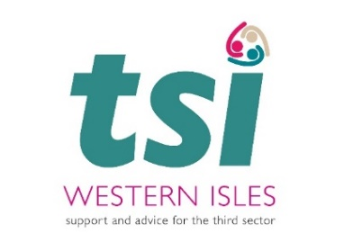

The Communities Mental Health and Wellbeing Fund for Adults opens for Fifth and Sixth years
Years 5 & 6 of the Communities Mental Health and Wellbeing Fund for Adults offers financial support to local community projects that improve the mental health and wellbeing of people living in the Western Isles.

This Scottish Government fund will support small to medium sized community groups, voluntary organisations and social enterprises to deliver adult mental health and wellbeing projects throughout the Islands archipelago. The Scottish Government has allocated £97,000 in Year 5 (2025-26) and a further £97,000 in Year 6 (2026-27). This money will be distributed to groups who provide community support and connections for people who have experienced distress, disadvantage, isolation, or whose mental health has been negatively impacted by the ongoing cost-of-living crisis.
The overarching aim of the Fund is to promote and develop good mental health and wellbeing while mitigating the impact of distress and mental ill health within the adult population (aged 16 or over) with a particular focus on prevention and early intervention. Key priorities include:
a). Addressing mental health inequalities within ‘at risk’ groups.
b). Tackling social isolation, loneliness, suicide prevention, and poverty and inequality, with a focus on responding to the cost-of-living crisis.
c). Supporting small grassroots community groups and organisations in delivering activities.
d). Fostering connections, building trusted relationships, and revitalising communities.
This initiative aligns directly with Outcome 4 of the Scottish Government’s Mental Health and Wellbeing Strategy published in June 2023, aiming to “better equip communities to support people’s mental health and wellbeing and provide opportunities to connect with others.”

Third Sector Interface Western Isles has distributed over £407,000 to 39 groups in the Western Isles across the previous four years of the fund. The fund has supported projects as diverse as arts, recreation, sporting memories, advocacy and counselling. As the cost-of-living crisis impacted our communities, funded projects have included Drop-in services providing warmth and food for the most vulnerable in our communities, music therapy, gaining and improving skills in woodwork and gardening, exercise, befriending, counselling and much more. 42% of awards have been made to projects whose value is in the range of £5,000 - £10,000 while 58% of awards have been made to projects valued under £5,000, meaning that most of the money has been distributed to smaller groups to deliver support into small communities.

Applications from small-scale, local projects and those who haven’t previously applied to the fund will be especially welcome. TSI Western Isles would like applicants to consider how projects can result in lasting wellbeing benefits through partnership working, matched funding or increased volunteer participation.
The Western Isles Communities Mental Health and Wellbeing Fund is open from Monday 25th August 2025 and will close on Friday 31st October 2025.

Application Forms and Fund Guidance can be accessed at www.tsiwi.org or by emailing info@ucvo.org.uk

